Social Media Sentiment Analytics Dashboard

Dataset Overview:
- Source: OpenDataBay
- Period: 15 May 2010 – 23 October 2023
- Rows / Columns: 732 rows × 15 columns
- Description: Highlights user-generated content across countries and platforms. Shows audience engagement by sentiment, country, platform, and time.

Data Cleaning Steps:
- Renamed “Unnamed Column” to Index
- Converted Timestamp to proper date-time format
- Created new column Engage = Likes + Retweets
- Trimmed all text columns (hashtags, platform, users, country, text, sentiments)

Key Insights:
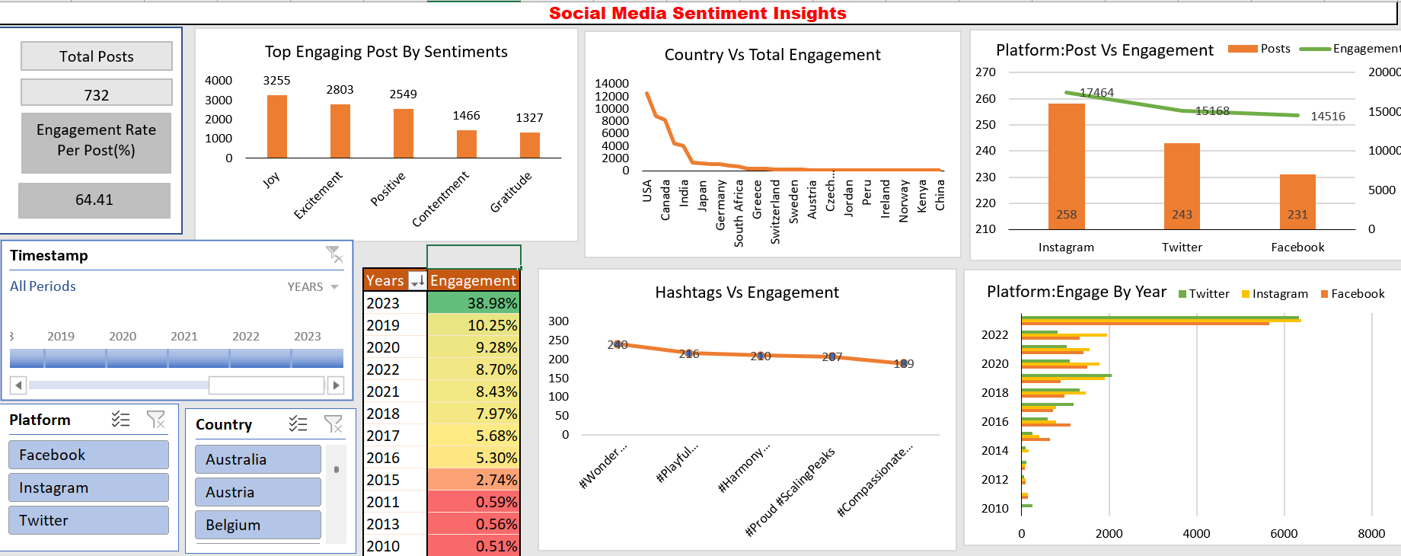
- Top Engaging Posts by Sentiment
| Sentiment | Engagement | Rank |
|-----------|-----------|------|
| Joy | 3255 | 1 |
| Excitement | 2803 | 2 |
| Positive | 2549 | 3 |
| Contentment | 1466 | 4 |
Observation: Posts with positive emotions (joy, excitement) receive higher engagement.

- Country vs Total Engagement
| Country | Total Engagement | Rank |
|---------|-----------------|------|
| USA | Highest | 1 |
| Canada | 2nd | 2 |
| China | Lowest | - |
Observation: USA and Canada audiences are highly active on social media, whereas China shows low engagement despite its large population.

- Platform: Posts vs Engagement
| Platform | Posts | Engagement | Rank |
|----------|-------|-----------|------|
| Instagram | 258 | 17,464 | 1 |
| Twitter | 243 | 15,618 | 2 |
| Facebook | 213 | 14,516 | 3 |
Observation: Engagement across platforms is relatively similar; Instagram leads slightly.

- Top Hashtags by Engagement
- #Wonder #StargazingAdventure → trending across all years
- #TimelessTunes #SeniorJazz → top in 2023
- #Radiance #SpringBlooms → top in 2022

- Platform Engagement Over Years
- Gradual increase in engagement from 2010 to 2022
- Sharp rise in 2023 (3–4× higher than previous years)
- Platform leadership:
  - 2014–2016 → Facebook
  - 2017–2019 → Instagram & Twitter
  - 2020–2022 → Instagram
  - 2023 → Twitter

- Yearly Engagement Contribution (%)
- 2023 → most active year (38.98%)
- 2020 → pandemic spike (10.25%)
Observation: Significant events (political news, sports, natural disasters) likely influenced engagement.

Conclusion (Portfolio-friendly, short):
The dashboard demonstrates how audience behavior varies across sentiments, platforms, countries, and years. Positive and joyful posts attract the most engagement. The USA and Canada are the most active regions. Platform engagement trends shift over time, with Instagram and Twitter alternating leadership. 2023 shows a remarkable surge, highlighting the impact of major events on social media activity.

